**ASSIGNMENT-6**

U19CS012

**1.** Determine and plot the output voltage for the given circuit. Also verify the same using Multisim.



(I) Multisim Calculations:

*1.) Circuit Image:*

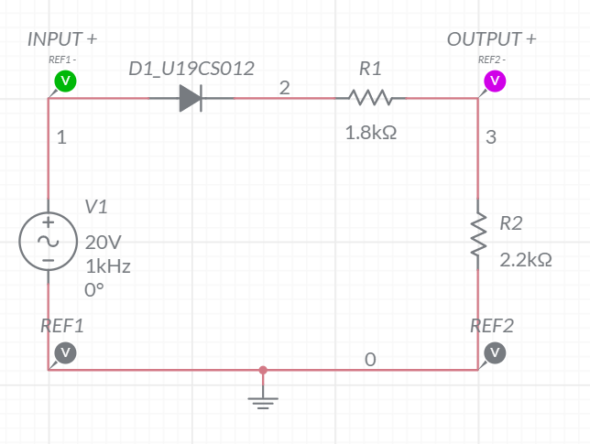

*2.) Grapher Image:*

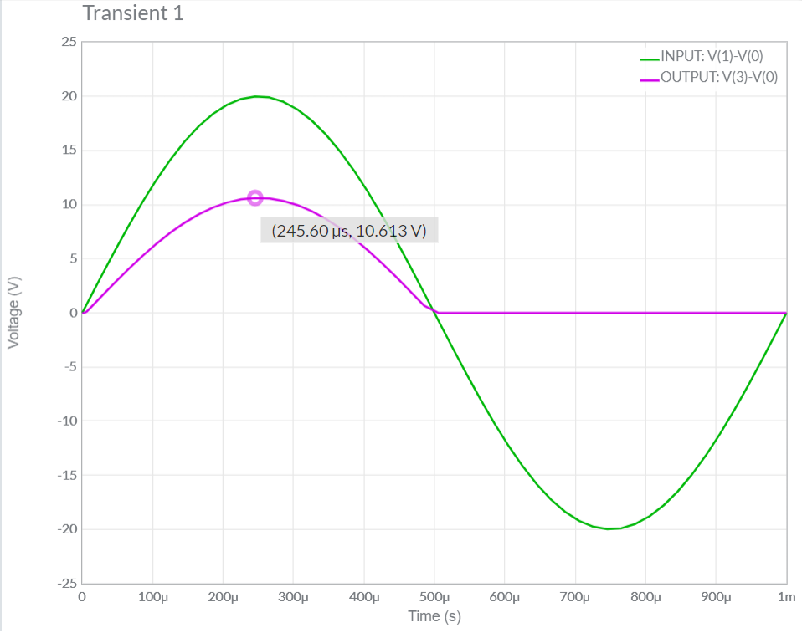

(II) Theoretical Calculations:

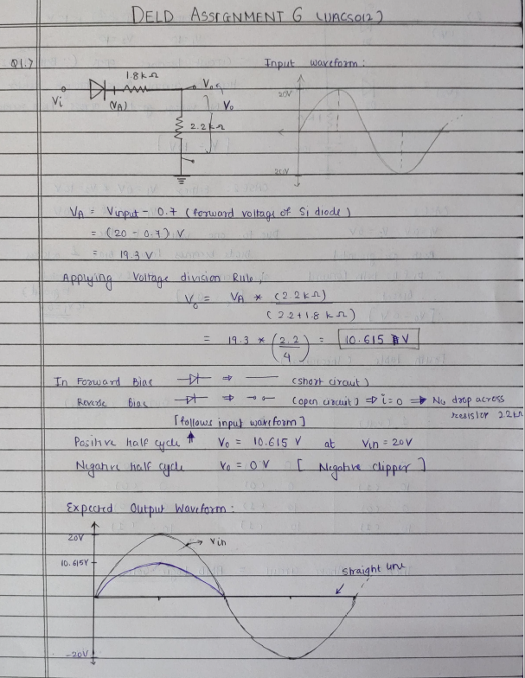

**2.** Identify the type of Logic Gate implemented by the below diode configuration. Also verify it using Multisim.



A.) Multisim Calculations:

*1.) Circuit Image:*

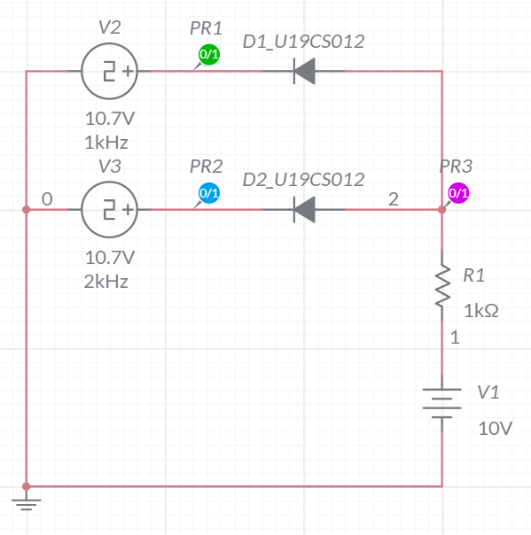

*2.) Grapher Image:*

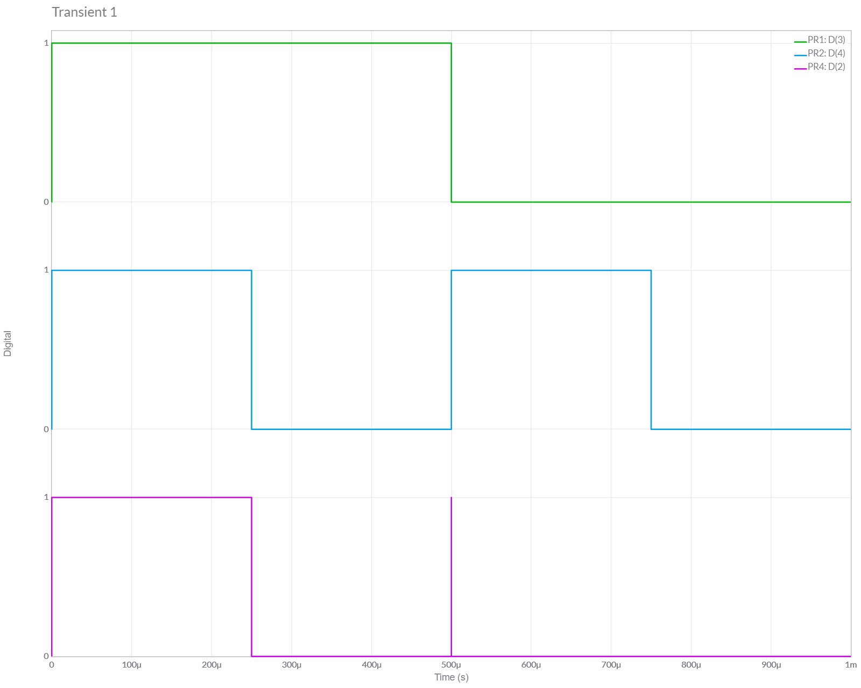

It Follows the Truth Table of AND Gate. [From Above Graph]

B.)Theoretical Calculations:

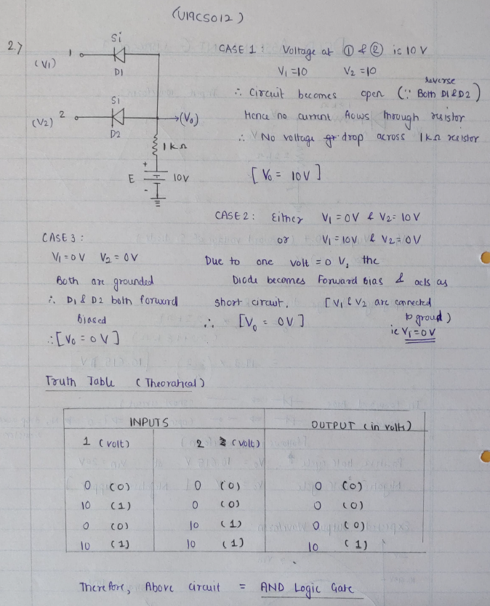

Hence, Circuit is Verified Successfully both theoretically & practically.

**3.** Draw the transfer characteristics for all the clipper configurations which are part of your today’s practical (Practical – 6).



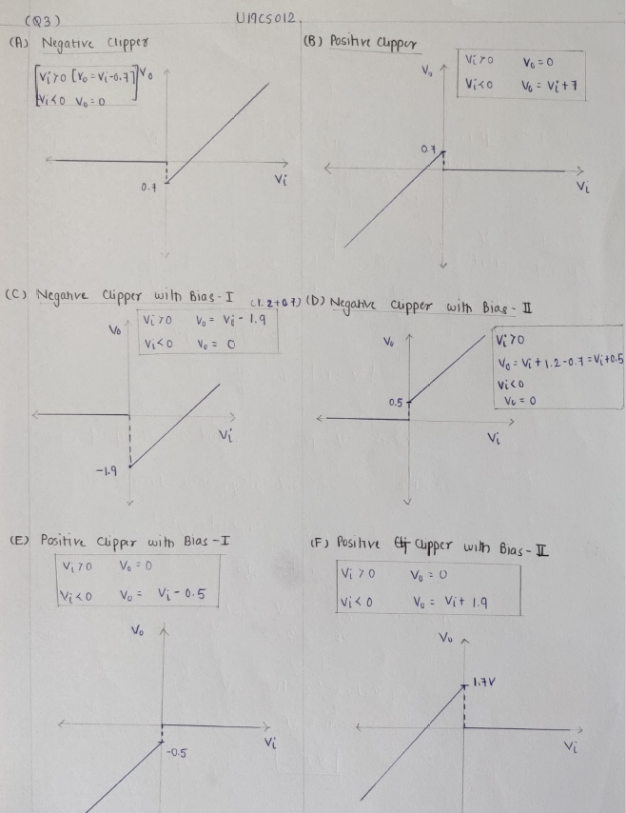

**4.** Assuming Symmetrical Sine wave input with peak value greater than the reference voltage, predict the output and plot the Transfer Characteristics for the following Clipper Circuits:

A.)



I.)Theoretical Calculations:

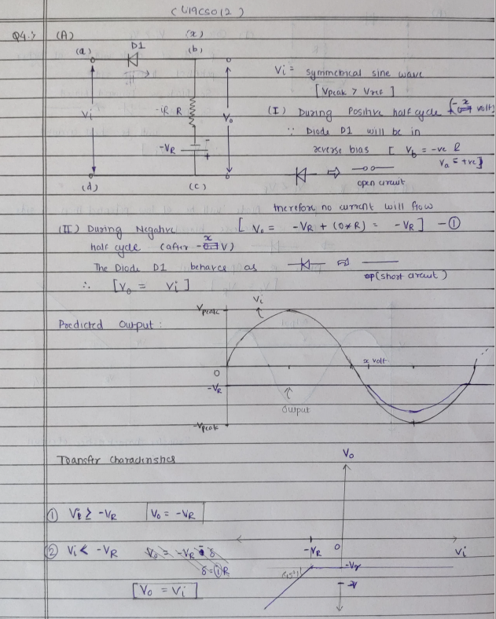

*1.) Circuit Image:*

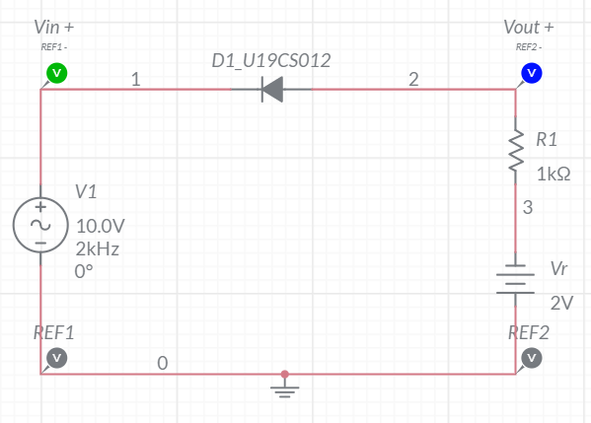

*2.) Grapher Image:*

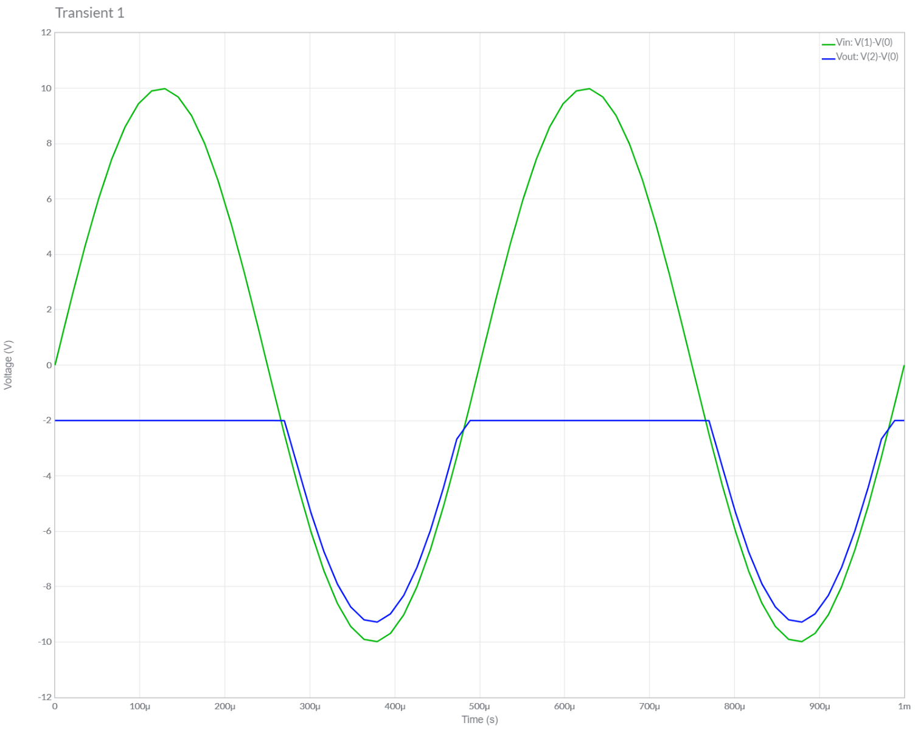

B.)



I.)Theoretical Calculations:

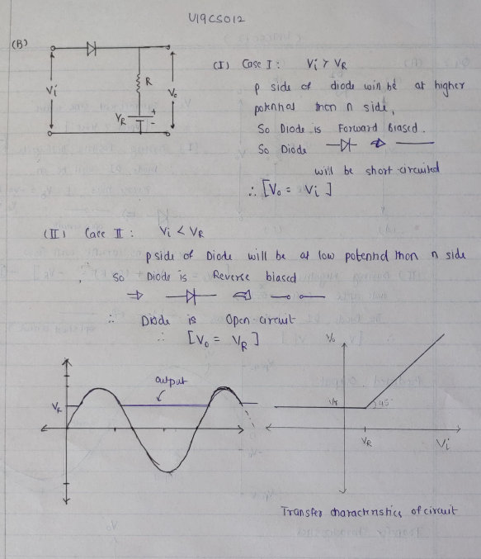

*1.) Circuit Image:*

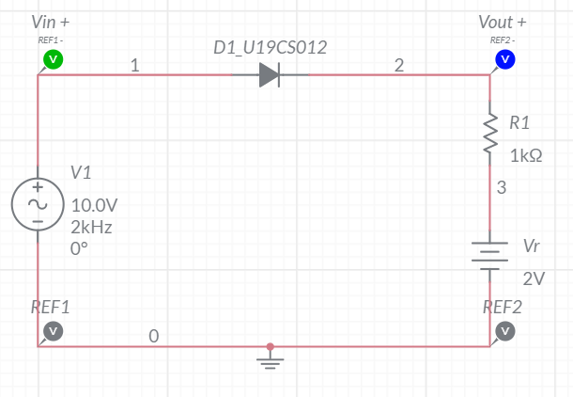

*2.) Grapher Image:*

